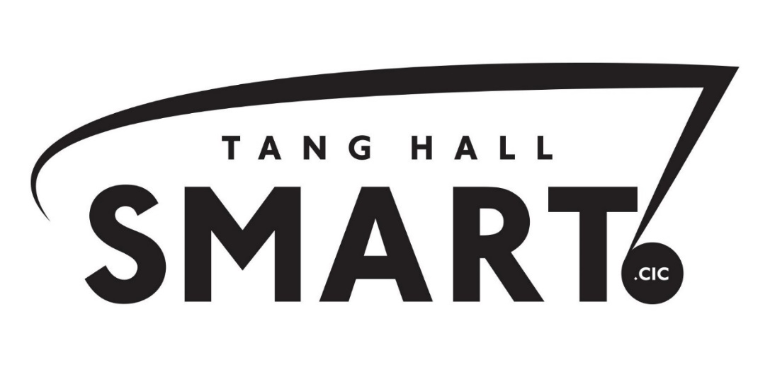
Health and safety policy
1. This policy will say how Tang Hall SMART CIC will manage its health and safety responsibilities.
2. We will manage health and safety by:
2.1 Controlling the health and safety risks at work.
2.2 Involving employees on health and safety issues that affect them.
2.3 Making sure that where employees work, and any equipment they use, is safe.
2.4 Making sure that dangerous substances are stored and used safely.
2.5 Making sure employees, especially new employees, have relevant information and training on health and safety.
2.6 Making sure employees can do their jobs, and are properly trained.
2.7 Trying to stop accidents and work-related health problems.
2.8 Regularly checking that working conditions are safe and healthy for staff and clients.
2.9 Regularly reviewing this policy and making changes if necessary.

3. Responsibility for health and safety
Overall responsibility for health and safety belongs to the board of Directors of Tang Hall SMART CIC
Daily responsibility for managing this policy is given to Alex Williamson (Director)
The following people have responsibilities for health and safety:
1) Emergency Evacuation – in case of fire or other emergency, Alex Williamson.
2) H&S induction – Alex Williamson
3) H&S risk assessment – Alex and Sue Williamson
4) First Aider – Alex Williamson, Linda Davies and Gareth Wilcox
5) Accident recording, investigating and reporting – Alex and Sue Williamson
6. Employees are responsible for:
6.1 Co-operating with people who are responsible for health and safety.
6.2 Using safety equipment when it is necessary.
6.3 Taking care of their own health and safety.
6.4 Reporting health and safety concerns to the right person as written in this policy.

4. Controlling the health and safety risks at work
Alex Williamson will do regular health and safety risk assessments.
The results of the risk assessment will be given to Sue Williamson and will be included with this policy.
Sue Williamson should agree any action needed to manage the risks that have been found.
Assessments will be carried out every 12 months, or when there is a change to the way we work.

5. Risk Assessments
A risk assessment is, as the Health and Safety Executive (HSE) describe: "a careful examination of what, in your work, could cause harm to people.... the aim is to make sure that no one gets hurt or becomes ill". Appendix A outlines the process we will take to assess risk.

6. Making sure that the workplace and equipment are safe
Alex Williamson will be responsible for making sure that there is a maintenance procedure for the workplace and any equipment being used.
Alex Williamson will be responsible for checking to see if any equipment being used for work, or parts of the workplace, need maintenance.
Alex Williamson will be responsible for making sure that all the necessary maintenance is done.
Any problems with work equipment or the workplace should be reported to Alex Williamson.
Before buying any equipment or changing where people work, Alex Williamson will check that health and safety standards are met.

7. Using and storing dangerous substances
Alex Williamson will check if any substances being used at work need COSHH (Control of Substances Hazardous to Health) assessment. He will do the COSHH assessments, and ensure that any action points from the COSHH assessments are implemented. Alex Williamson will make sure all employees are told about the COSHH assessments and will check how to use new substances safely before they are bought.
COSHH assessments will be reviewed every 12months, or when there is a change to the way we work.
Tang Hall SMART CIC is aware that things we are using, e.g. bleach, paints, as well as things like fumes or dust or gas that are produced when you work could be a dangerous substance.
Our assessment will consider the possible ill-effects that we should then do something about, perhaps by warning people, using hazard signs, training users, using protective equipment, improving ventilation and using safer alternatives.

8. Health and safety information and support
The Health and Safety Law poster is displayed in room 1 near the door.
The current employers’ liability insurance certificate is displayed in room 1 near the door.
Health and safety advice is available from Alex or Sue Williamson.
People using any equipment for the first time will be supervised by Alex Williamson.

9. Training and induction
This will be provided by Alex Williamson apart from roles that are more to do with safeguarding/lone worker policies, in which case training will be by Sue Williamson.
Food preparation/handling training is by Linda Davies.

10. Accidents and work related health problems
The first aid box is kept near the sink in room 1. Alex Williamson, Linda Davies and Gareth Wilcox are trained first aiders.
All accidents and work-related health problems should be recorded in the accident book by Sue Williamson. Sue Williamson is responsible for reporting accidents and diseases to the Health and Safety Executive.
Sue Williamson is responsible for health issues affecting work.
Both Alex and Sue Williamson are responsible for checking work conditions are safe and healthy
11. Investigations of accidents and near misses, and problems affecting work.
Alex Williamson is responsible for investigating accidents at work.
Sue Williamson is responsible for investigating work-related causes of absence and for working with staff who are experiencing health problems/disabilities that are affecting their work.
Alex or Sue Williamson are responsible for acting on the results of the investigation to stop the same

12. Fire and evacuation
Alex Williamson is responsible for making sure that the fire risk assessment is done and any action points are carried out. Escape routes are checked by Matthew Shield for York City Council at least every 6 months. YCC are responsible for Fire extinguishers, that they are maintained and checked. The fire alarm is tested by Alex Williamson and Wayne Gorst for YCC weekly.
Emergency evacuation will be tested every 6 months by YCC.
The evacuation procedure is: If the alarm sounds
• Evacuate the building immediately by the nearest exit
• Ensure any visitors leave the building by sweeping the area including the toilets.
• Do not put yourself at risk
• Assemble in front of the building in the carpark.
• Do not re-enter the building for any reason until the Fire Officer or fire brigade confirm that it is safe to do so.
If you discover a fire
• Raise the alarm by operating the break glass switch on the wall near the toilets
• Evacuate the building immediately as above.

13. Stress at work
Any member of staff who is experiencing stress is encouraged to alert Sue Williamson as soon as possible for a confidential discussion, and so that any adjustments can be made to improve the experience of work.
14. Lone worker policy
As Tang Hall SMART CIC focuses on well-being, it is likely that from time to time, one-to-one discussions will take place between staff members and clients. In this event, these discussions should take place either in the usual delivery rooms, the office with the glass wall, or in a public place in the event that the discussion is scheduled for out of work hours, such as a café. Staff are advised not to visit the homes of clients on their own, but to attend with a second member of staff or a professional from another service.
15. Electricity and electrical equipment
PAT testing is carried out yearly. Alex Williamson is responsible for ensuring electrical items function.
16. Food hygiene
Is the responsibility of Linda Davies.
17. Noise levels
These are monitored by Alex Williamson. Ear defenders are provided for staff and clients who require protection. It is their responsibility to ask for these.

18. Slips, trips and falls
All staff are responsible for ensuring that the rooms are in a safe and ordered state, ready for delivery so that staff and clients are unlikely to slip, trip or fall. In the event that they do, then first aid procedures should be followed.
19. Violence to staff
All actual or threatened violence, whether verbal or physical should be referred to Sue Williamson for her attention and action.
20. Staff and clients with disabilities, eg in relation to fire and evacuation procedures
All staff members are responsible for ensuring safe evacuation of people with disabilities.

January 2017 – to be reviewed January 2018

